Volume

1

Digital Board marker

Storage Efficient System for Class Lectures

Administrative Style Sheet Guide

Digital Board Marker

Administrative Style Sheet Guide

© Digital Board Marker

University of Engineering and Technology, Main Campus

GT Rd. 54000

Phone (042) 99029227

Table of Contents

Setting up Hardware Environment 1

Installation of Controller Application 5

Configuration of Controller Application 6

Camera Connection 6

Marker Connection 7

Recording the video 11

Playing the video 13

Chapter

1

Setting up Hardware Environment

This chapter is about setting up the hardware environment.

F

irst of all, we will talk about setting up the camera view and their connection with the computer. We will make sure that all modules are working fine and connected.

1. To make sure that camera modules are working for the application, Plug the camera in via USB port to a PC. You will see the camera driver will be automatically installed. If there is compatibility issue then install the appropriate drivers according to your operating system.  
     
   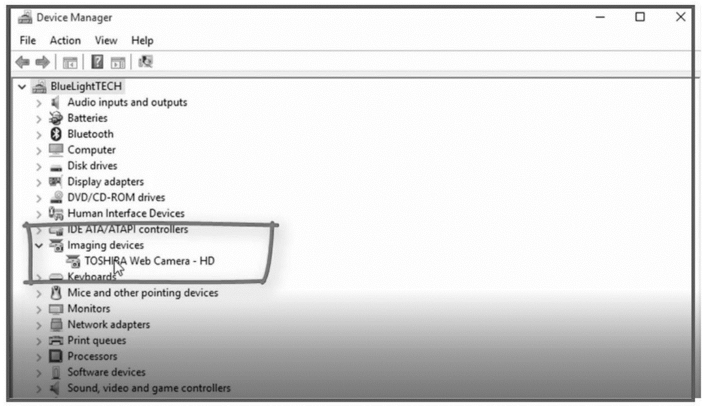
2. Adjust the camera view according to the board. To make sure this thing, put the each of the camera to upper corners of the board so that each camera will get the whole one side view of the board with corners touching image boundary.  
   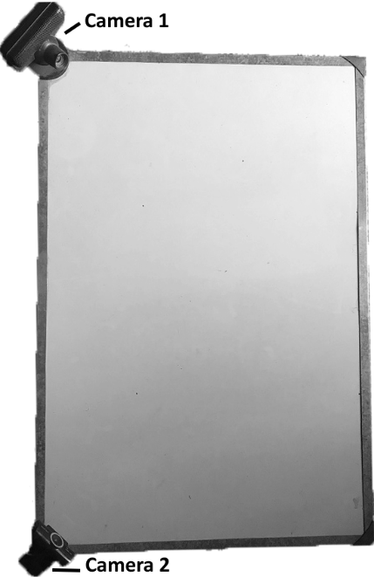  
     
   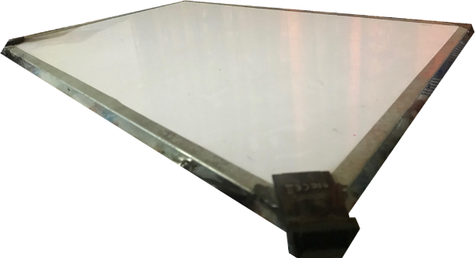
3. Connect the marker hardware receiver to the computer and install the following drivers and software if needed
   1. RS-232 USB to Serial
   2. Arduino IDE
4. Turn on the marker hardware. Marker light will
   1. Fade blue with interval of 2s when not connected
   2. Glow red constantly when connected
5. Open Arduino IDE and go to TOOLS
   1. Select the appropriate serial port e.g. COM 3
   2. Select Arduino nano from Board section

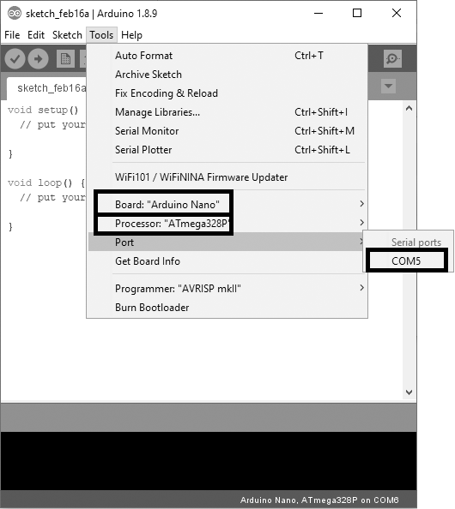

1. Start serial monitor and if you see data packets received, you are done setting up the hardware

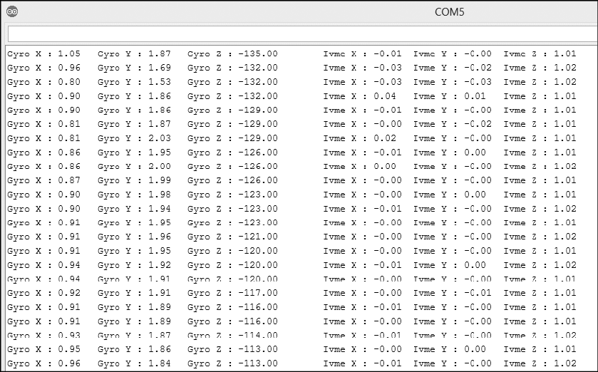

Chapter

2

Installation of Controller Application

This chapter is about installation of the controller application.

F

irst of all, we will talk about installation of the controller application.

1. Install the controller application by running the setup and selecting the appropriate directory.
2. After installation, start the application. You will see the application screen like this

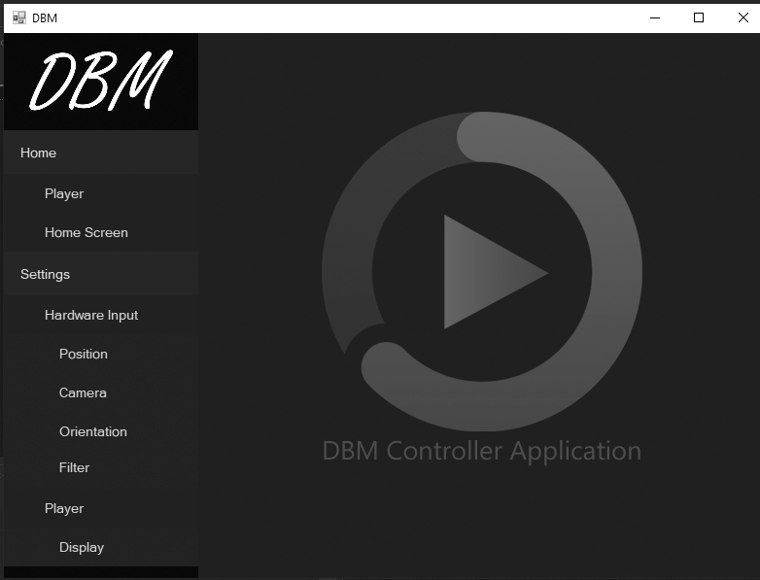

1. If you see the screen, you have done application installation.

Chapter

3

Configuration of Controller Application

This chapter is about hardware configuration of the controller application.

F

irst of all, we will talk about configuration of the controller application with hardware connected.

## Camera Connection

1. Connect the marker hardware to PC and start the controller application
2. Go to Settings->Camera
3. Select Left as **Camera 1**
4. Set appropriate **FPS** e.g. 120
5. Click on **Capture** button
6. Click on **Preview** button to make sure camera is working fine
7. Do the steps from 1 to 6 with Camera 2

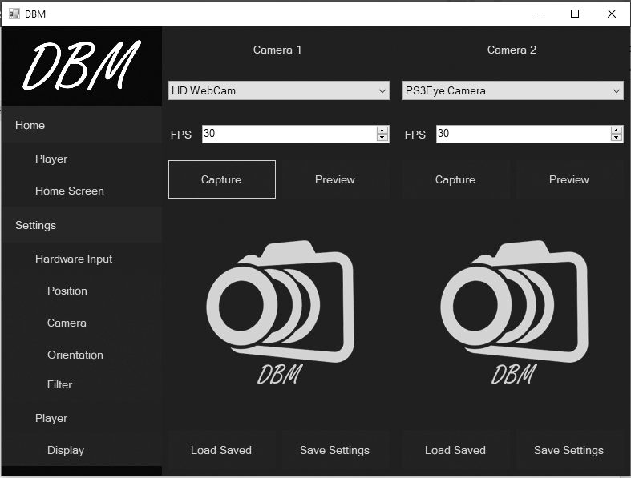

## Marker Connection

1. Connect the receiver with PC and turn on the marker.
2. Go to **Orientation**
3. Select appropriate serial port e.g. COM 4 and click on **Start Serial**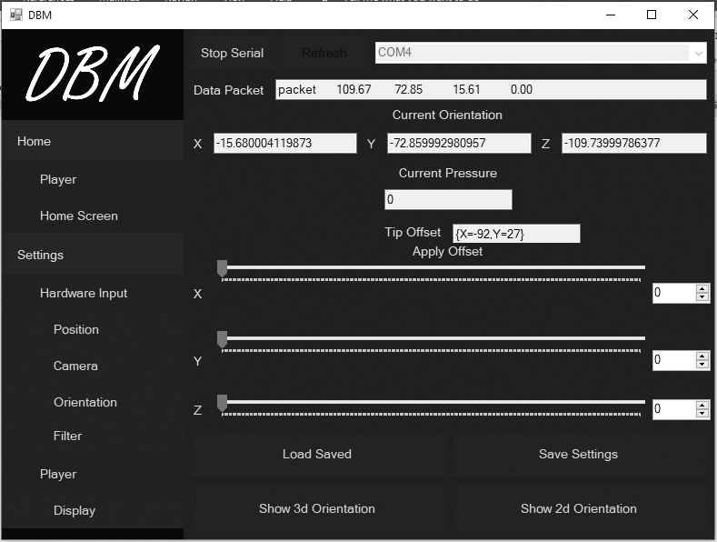
4. Click on **Show 3d Orientation** and adjust the marker rotation by changing the respective **Trackbars**

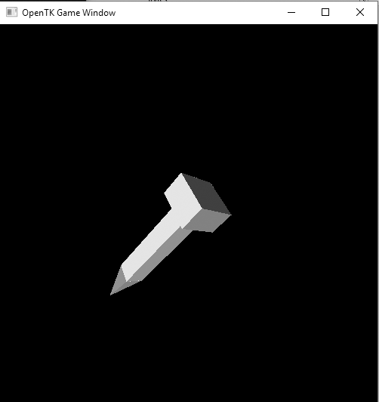

1. You can also adjust by clicking on **Show 2d Orientation**

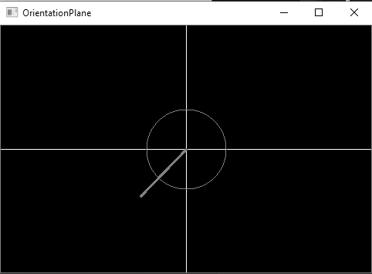

1. Filter settings are already set and saved. Although you can adjust them as well by clicking the **Filter** button from left navigation bar

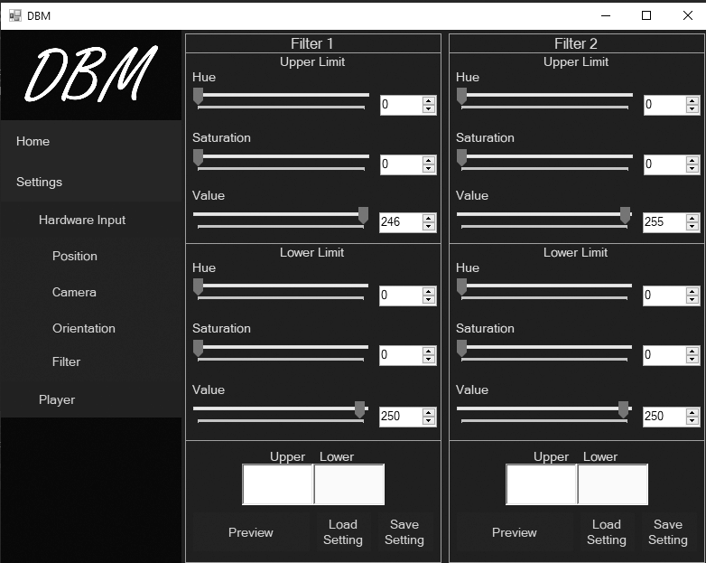

1. To visualize filter settings, click on **Preview** button

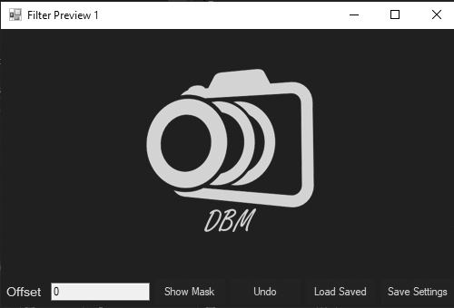

1. Click on **Show Mask** to view the filter adjustment
2. Place points by clicking the mouse double click
3. Click **Undo** button to delete last point placed
4. Click on **Position** from side navigation menu and visualize the final position

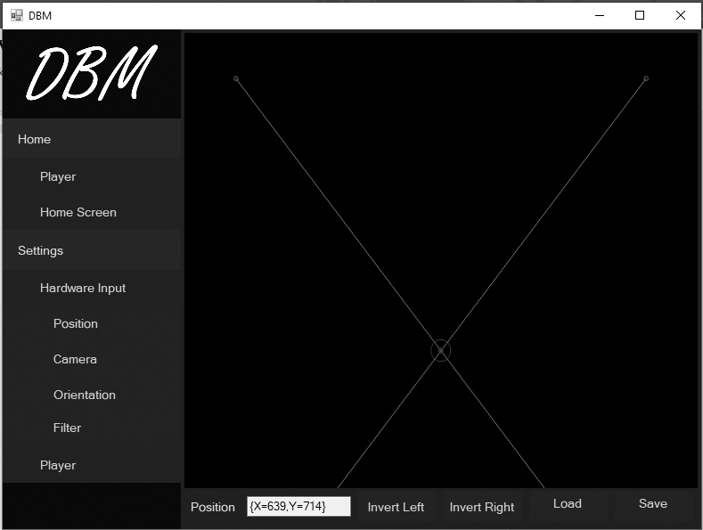

Chapter

4

Recording the video

This chapter is about recording the first video.

F

irst of all, we will talk about recording the video using controller application.

1. Start controller application and click on **Player** from side navigation bar
2. Click on **Enable Hardware Input** button
3. Adjust the record delays using **Tick Resolution**. Smaller the tick resolution, finer the quality and larger the size of the output file
4. Click on **Start Recording** and write something on the board
5. You can change the marker color by clicking on **Color**
6. You can adjust thickness of line drawn by adjusting the **Thickness** trackbar
7. Click on **Stop Recording** to stop the video record
8. Click on **Save File** button and choose the directory folder where you want to save the file

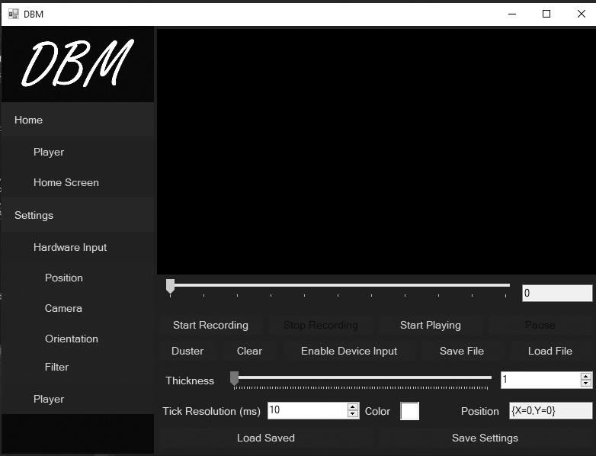

Chapter

5

Playing the video

This chapter is about playing the video file.

F

irst of all, we will talk about playing the video using controller application.

1. Start controller application and click on **Player** from side navigation bar
2. Click on **Load File** and choose a lecture file with **“.dbm”** extension
3. Click on **Start Playing** to start the video

